
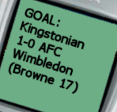

Kingstonian FC

Text Alerts
with kingstonian.net

Sign up for Kingstonian Text Alerts and you’ll receive a text message telling you
- Whenever a goal is scored in a competitive match
- The half-time and full-time score from every match
- All major news items – including FA Cup/Trophy draws
All of this can be yours for just £40 for the entire 2003/2004 season

Ooh yeah, sign me up…..

Name

Email (optional)

Mobile number

Mobile network

Duration £40 Entire season (August – May)

£20 Half season (August – December)

Please make all cheques payable to “The K’s Trust”
and return this form and payment to

Text Alerts, The K’s Trust, PO Box 1258,
Kingston upon Thames, KT1 3WW

All proceeds go to The K’s Trust

