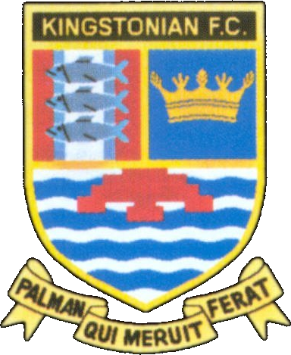
Kingstonian FC

Fixtures 2004/2005
www.kingstonian.net

Date | H/A | Opponent | Comp | Score | Attd | Scorers
Sat 14th Aug | A | Leyton | Isthmian | -
Mon 16th Aug | H | Wealdstone | Isthmian | -
Sat 21st Aug | H | Heybridge Swifts | Isthmian | -
Tue 24th Aug | A | Salisbury City | Isthmian | -
Sat 28th Aug | A | Windsor & Eton | Isthmian | -
Mon 30th Aug | H | Yeading | Isthmian | -
Sat 4th Sep | A | Tonbridge Angels | Isthmian | -
Mon 6th Sep | H | Dover Athletic | Isthmian | -
Sat 11th Sep | H | Harrow Borough | Isthmian | -
Tue 14th Sep | A | Worthing | Isthmian | -
Sat 18th Sep | H | Lancing / Ramsgate | FAC 1Q | -
Sat 25th Sep | A | Billericay Town | Isthmian | -
Sat 9th Oct | H | Northwood | Isthmian | -
Mon 11th Oct | H | Slough Town | Isthmian | -
Sat 16th Oct | A | Braintree Town | Isthmian | -
Wed 20th Oct | A | Eastleigh | Isthmian | -
Sat 23rd Oct | H | Hendon | Isthmian | -
Wed 27th Oct |  |  | Bryco 1 | -
Sat 30th Oct | A | Cheshunt | Isthmian | -
Sat 6th Nov | H | Bishop’s Stortford | FAT 1 | -
Sat 13th Nov | H | Staines Town | Isthmian | -
Sat 20th Nov | A | Folkestone Invicta | Isthmian | -
Sat 4th Dec | H | Chelmsford City | Isthmian | -
Sat 11th Dec | H | Leyton | Isthmian | -
Sat 18th Dec | A | Wealdstone | Isthmian | -
Mon 27th Dec | H | Hampton & Richmond Borough | Isthmian | -
Sat 1st Jan | A | Yeading | Isthmian | -
Sat 8th Jan | H | Tonbridge Angels | Isthmian | -
Sat 15th Jan | A | Dover | Isthmian | -
Sat 22nd Jan | H | Worthing | Isthmian | -
Sat 29th Jan | A | Harrow Borough | Isthmian | -
Sat 5th Feb | H | Billericay Town | Isthmian | -
Sat 12th Feb | A | Northwood | Isthmian | -
Sat 19th Feb | H | Braintree Town | Isthmian | -
Sat 26th Feb | A | Slough Town | Isthmian | -
Sat 5th Mar | H | Eastleigh | Isthmian | -
Sat 12th Mar | A | Hendon | Isthmian | -
Sat 19th Mar | A | Heybridge Swifts | Isthmian | -
Sat 26th Mar | H | Salisbury City | Isthmian | -
Mon 28th Mar | A | Hampton & Richmond Borough | Isthmian | -
Sat 2nd Apr | H | Windsor & Eton | Isthmian | -
Sat 9th Apr | A | Staines Town | Isthmian | -
Sat 16th Apr | H | Cheshunt | Isthmian | -
Sat 23rd Apr | A | Chelmsford City | Isthmian | -
Sat 30th Apr | H | Folkestone Invicta | Isthmian | -

Cup Dates
FA Cup 1Q Sat 18th Sep 2Q Sat 2nd Oct 3Q Sat 16th Oct 4Q Sat 30th Oct 1 Sat 13th Nov 2 Sat 4th Dec
3 Sat 8th Jan 4 Sat 29th Jan 5 Sat 19th Feb 6 Sat 12th Mar SF Sat 16th Apr F Sat 21st May

FA Trophy 1 Sat 6th Nov 2 Sat 27th Nov 3 Sat 15th Jan 4 Sat 5th Feb 5 Sat 26th Feb 6 Sat 12th Mar
SF1 Sat 2nd Apr SF2 Sat 9th Apr F Sun 22nd May

Bryco Cup 1 Wed 27th Oct 2 Wed 17th Nov 3 Mon 3rd Jan 4 Wed 2nd Feb 5 Wed 23rd Feb SF1 Wed 16th Mar
SF2 Wed 23rd Mar F Mon 2nd May

Please note - all fixtures are subject to change. For up to date information on all

Kingstonian fixtures, visit the official web site for Kingstonian FC: www.kingstonian.net.

