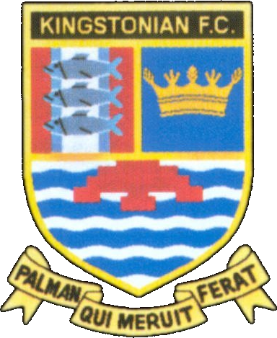
Kingstonian FC - Fixtures 2005/2006
www.kingstonian.net

Date | H/A | Opponent | Comp | Score | Attd | Scorers
Sat 20th Aug | A | Leatherhead | Isthmian | -
Mon 22nd Aug | H | Newport IoW | Isthmian | -
Sat 27th Aug | H | Ringmer | FAC P | -
Mon 29th Aug | A | Whyteleafe | Isthmian | -
Sat 3rd Sep | H | Molesey | Isthmian | -
Tue 6th Sep | A | Lymington & New Milton | LC 1 | -
Sat 10th Sep | A | Steyning Town / Cray W | FAC 1Q | -
Sat 17th Sep | A | Burgess Hill Town | Isthmian | -
Wed 21st Sep | A | Ashford Town | Isthmian | -
Sat 24th Sep | H | Tonbridge Angels | Isthmian | -
Tue 27th Sep | A | Metropolitan Police | Isthmian | -
Sat 1st Oct | H | Horsham | Isthmian | -
Mon 3rd Oct | H | Bashley | Isthmian | -
Sat 8th Oct | A | Corinthian Casuals | Isthmian | -
Sun 16th Oct | H | Aveley | FAT 1Q | -
Sat 22nd Oct | A | Cray Wanderers | Isthmian | -
Mon 24th Oct | H | Banstead Athletic | Isthmian | -
Sat 29th Oct | H | Dulwich Hamlet | Isthmian | -
Tue 1st Nov | A | Croydon Athletic | Isthmian | -
Sat 5th Nov | A | Fleet Town | Isthmian | -
Sat 12th Nov | A | Enfield / Fleet Town | FAT 2Q | -
Sat 19th Nov
Tue 22nd Nov | A | Ramsgate | Isthmian | -
Sat 26th Nov | H | Tooting & Mitcham United | Isthmian | -
Mon 28th Nov | H | Ashford Town | Isthmian | -
Sat 3rd Dec | A | Dover Athletic | Isthmian | -
Mon 5th Dec | H | Ramsgate | Isthmian | -
Sat 10th Dec | A | Lymington & New Milton | Isthmian | -
Sat 17th Dec | H | Hastings United | Isthmian | -
Mon 26th Dec | A | Walton Casuals | Isthmian | -
Mon 2nd Jan | H | Whyteleafe | Isthmian | -
Sat 7th Jan | H | Leatherhead | Isthmian | -
Sat 14th Jan | A | Newport IoW | Isthmian | -
Sat 21st Jan | H | Burgess Hill Town | Isthmian | -
Sat 28th Jan | A | Molesey | Isthmian | -
Sat 4th Feb | H | Dover Athletic | Isthmian | -
Sat 11th Feb | A | Tooting & Mitcham United | Isthmian | -
Sat 18th Feb | A | Dulwich Hamlet | Isthmian | -
Sat 25th Feb | H | Cray Wanderers | Isthmian | -
Tue 28th Feb | A | Banstead Athletic | Isthmian | -
Sat 4th Mar | H | Fleet Town | Isthmian | -
Mon 6th Mar | H | Croydon Athletic | Isthmian | -
Sat 11th Mar
Sat 18th Mar | A | Horsham | Isthmian | -
Sat 25th Mar | H | Metropolitan Police | Isthmian | -
Sat 1st Apr | A | Bashley | Isthmian | -
Sat 8th Apr | H | Corinthian Casuals | Isthmian | -
Sat 15th Apr | A | Tonbridge Angels | Isthmian | -
Mon 17th Apr | H | Walton Casuals | Isthmian | -
Sat 22nd Apr | H | Lymington & New Milton | Isthmian | -
Sat 29th Apr | A | Hastings United | Isthmian | -

FA Cup 1Q Sat 10th Sep 2Q Sat 24th Sep 3Q Sat 8th Oct 4Q Sat 22nd Oct 1 Sat 5th Nov 2 Sat 3rd Dec
3 Sat 7th Jan 4 Sat 28th Jan 5 Sat 18th Feb 6 Wed 22nd Mar SF Sat 22nd Apr F Sat 13th May

FA Trophy 1Q Sat 15th Oct 2Q Sat 12th Nov 3Q Sat 26th Nov 1 Sat 17th Dec 2 Sat 14th Jan
3 Sat 4th Feb 4 Sat 25th Feb SF1 Sat 18th Mar SF2 Sat 25th Mar F Sun 14th May

League Cup 1 Tue 6th Sep

Please note - all fixtures are subject to change. For up to date information visit the official Kingstonian FC website.

