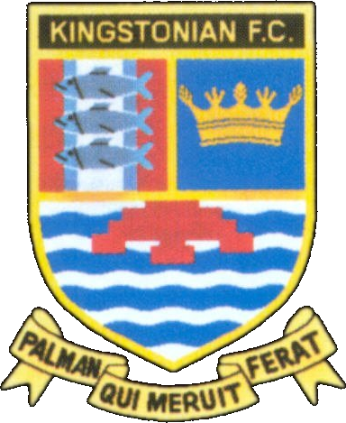
Kingstonian FC - Fixtures 2006/2007
www.kingstonian.net

Date | H/A | Opponent | Comp | Score | Attd | Scorers
Sat 19th Aug | H | Ashford Town | Isthmian | -
Tue 22nd Aug | A | Croydon Athletic | Isthmian | -
Sat 26th Aug | A | Dartford | Isthmian | -
Mon 28th Aug | H | Horsham YMCA | Isthmian | -
Sat 2nd Sep* | H | Pagham | FAC P | -
Sat 9th Sep | A | Godalming Town | Isthmian | -
Sat 16th Sep* | H | Ramsgate | FAC 1Q | -
Mon 18th Sep | H | Corinthian Casuals | Isthmian | -
Sat 23rd Sep | H | Chatham Town | Isthmian | -
Sat 30th Sep | A | Walton Casuals | Isthmian | -
Sat 7th Oct | A | Dover Athletic | Isthmian | -
Sat 14th Oct | H | Fleet Town | Isthmian | -
Tue 17th Oct | A | Whyteleafe | Isthmian | -
Sat 21st Oct | A | Chatham Town / AFC Sudbury | FAT 1Q | -
Sat 28th Oct | A | Tooting & Mitcham United | Isthmian | -
Mon 30th Oct | H | Metropolitan Police | Isthmian | -
Sat 4th Nov |  | No fixture
Sat 11th Nov | H | Hastings United | Isthmian | -
Sat 18th Nov | A | Sittingbourne | Isthmian | -
Tue 21st Nov | A | Metropolitan Police | Isthmian | -
Sat 25th Nov | H | Cray Wanderers | Isthmian | -
Sat 2nd Dec | A | Dulwich Hamlet | Isthmian | -
Sat 9th Dec | H | Molesey | Isthmian | -
Sat 16th Dec | A | Burgess Hill Town | Isthmian | -
Sat 23rd Dec | H | Maidstone United | Isthmian | -
Tue 26th Dec | H | Leatherhead | Isthmian | -
Sat 30th Dec | A | Horsham YMCA | Isthmian | -
Sat 6th Jan | H | Croydon Athletic | Isthmian | -
Sat 13th Jan | A | Ashford Town | Isthmian | -
Sat 20th Jan | H | Dover Athletic | Isthmian | -
Sat 27th Jan | A | Hastings United | Isthmian | -
Sat 3rd Feb | H | Sittingbourne | Isthmian | -
Sat 10th Feb | A | Cray Wanderers | Isthmian | -
Sat 17th Feb | H | Dulwich Hamlet | Isthmian | -
Sat 24th Feb | A | Molesey | Isthmian | -
Mon 26th Feb | H | Whyteleafe | Isthmian | -
Sat 3rd Mar | A | Chatham Town | Isthmian | -
Sat 10th Mar | H | Walton Casuals | Isthmian | -
Sat 17th Mar | A | Fleet Town | Isthmian | -
Sat 24th Mar | H | Tooting & Mitcham United | Isthmian | -
Sat 31st Mar | A | Corinthian Casuals | Isthmian | -
Sat 7th Apr | H | Dartford | Isthmian | -
Mon 9th Apr | A | Leatherhead | Isthmian | -
Sat 14th Apr | H | Godalming Town | Isthmian | -
Sat 21st Apr | A | Maidstone United | Isthmian | -
Sat 28th Apr | H | Burgess Hill Town | Isthmian | -

FA Cup 1Q Sat 16th Sep 2Q Sat 30th Sep 3Q Sat 14th Oct 4Q Sat 28th Oct 1 Sat 11th Nov 2 Sat 2nd Dec
3 Sat 6th Jan 4 Sat 27th Jan 5 Sat 17th Feb 6 Sat 10th Mar SF Sat 14th Apr F Sat 19th May

FA Trophy 1Q Sat 21st Oct 2Q Sat 4th Nov 3Q Sat 25th Nov 1 Sat 16th Dec 2 Sat 13th Jan
3 Sat 3rd Feb 4 Sat 24th Feb SF1 Sat 10th Mar SF2 Sat 17th Mar F Sun 20th May

League Cup

Please note - All fixtures are subject to change * To be played on the Friday evening or Sunday afternoon
For up to date information visit the official Kingstonian FC website

