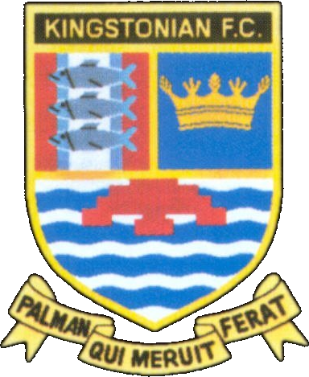
Kingstonian FC - Fixtures 2007/2008
www.kingstonian.net

Date | H/A | Opponent | Comp | Score | Att | Scorers
Sat 18th Aug | A | Ashford Town | Isthmian | -
Mon 20th Aug | H | Corinthian Casuals | Isthmian | -
Sat 25th Aug | H | Horsham YMCA | Isthmian | -
Mon 27th Aug | A | Tooting & Mitcham United | Isthmian | -
Sat 1st Sep | A | Eastbourne Town | FAC P | -
Sat 8th Sep | H | Molesey | Isthmian | -
Sat 15th Sep | H |  | FAC 1Q
Fri 21st Sep | A | Dulwich Hamlet | Isthmian | -
Mon 24th Sep | H | Walton Casuals | Isthmian | -
Sat 29th Sep | A | Dover Athletic | Isthmian | -
Sat 6th Oct | A | Chatham Town | FAT P | -
Sat 13th Oct | H | Sittingbourne | Isthmian | -
Tue 16th Oct | A | Chipstead | Isthmian | -
Sun 20th Oct | H |  | FAT 1Q
Sat 27th Oct | H | Chatham Town | Isthmian | -
Tue 30th Oct | A | Croydon Athletic | Isthmian | -
Sat 3rd Nov | A | Eastbourne Town | Isthmian | -
Mon 5th Nov | H | Whyteleafe | Isthmian | -
Sat 10th Nov | A | Burgess Hill Town | Isthmian | -
Sat 17th Nov | H | Walton & Hersham | Isthmian | -
Mon 19th Nov | H | Metropolitan Police | Isthmian | -
Sat 24th Nov | A | Whitstable Town | Isthmian | -
Sat 1st Dec | A | Worthing | Isthmian | -
Sat 8th Dec | H | Cray Wanderers | Isthmian | -
Sat 15th Dec | A | Corinthian Casuals | Isthmian | -
Sat 22nd Dec | H | Ashford Town | Isthmian | -
Wed 26th Dec | A | Leatherhead | Isthmian | -
Sat 29th Dec | H | Tooting & Mitcham United | Isthmian | -
Sat 5th Jan | H | Dover Athletic | Isthmian | -
Sat 12th Jan | A | Walton Casuals | Isthmian | -
Sat 19th Jan | H | Chipstead | Isthmian | -
Sat 26th Jan | A | Sittingbourne | Isthmian | -
Sat 2nd Feb | A | Molesey | Isthmian | -
Sat 9th Feb | H | Dulwich Hamlet | Isthmian | -
Sat 16th Feb | A | Walton & Hersham | Isthmian | -
Sat 23rd Feb | H | Burgess Hill Town | Isthmian | -
Sat 1st Mar | A | Metropolitan Police | Isthmian | -
Sat 8th Mar | H | Whitstable Town | Isthmian | -
Sat 15th Mar | H | Worthing | Isthmian | -
Sat 22nd Mar | A | Horsham YMCA | Isthmian | -
Mon 24th Mar | H | Leatherhead | Isthmian | -
Fri 28th Mar | A | Cray Wanderers | Isthmian | -
Sat 5th Apr | A | Chatham Town | Isthmian | -
Sat 12th Apr | H | Croydon Athletic | Isthmian | -
Sat 19th Apr | A | Whyteleafe | Isthmian | -
Sat 26th Apr | H | Eastbourne Town | Isthmian | -

FA Cup 1Q Sat 15th Sep 2Q Sat 29th Sep 3Q Sat 13th Oct 4Q Sat 27th Oct R1 Sat 10th Nov R2 Sat 1st Dec
R3 Sat 5th Jan R4 Sat 26th Jan R5 Sat 16th Feb R6 Sat 8th Mar SF Sat 5th Apr F Sat 17th May

FA Trophy 1Q Sat 20th Oct 2Q Sat 3rd Nov 3Q Sat 24th Nov R1 Sat 15th Dec R2 Sat 12th Jan
R3 Sat 2nd Feb R4 Sat 23rd Feb SF1 Sat 8th Mar SF2 Sat 15th Mar F Sat 10th May

League Cup

Fixtures are subject to change - for up to date information visit the official Kingstonian FC website

