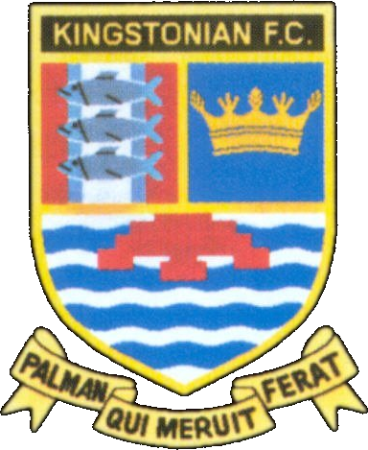
Kingstonian FC - Fixtures 2008/2009
www.kingstonian.net

Date | H/A | Opponent | Comp | Score | Att | Scorers
Sat 16th Aug | A | Sittingbourne | Isthmian | -
Mon 18th Aug | H | Fleet Town | Isthmian | -
Sat 23rd Aug | H | Whyteleafe | Isthmian | -
Mon 25th Aug | A | Croydon Athletic | Isthmian | -
Sat 30th Aug | A | Hassocks or Shoreham | FAC P | -
Sun 7th Sep | H | Burgess Hill Town | Isthmian | -
Tue 9th Sep | A | Walton & Hersham | Isthmian | -
Sat 13th Sep | H | Ashford Town or Leatherhead * | FAC 1Q
Sat 20th Sep | A | Walton Casuals | Isthmian | -
Mon 22nd Sep | H | Leatherhead | Isthmian | -
Sat 27th Sep | H | Worthing | Isthmian | -
Wed 1st Oct | A | Eastbourne Town | Isthmian | -
Sat 4th Oct | H | Whitstable Town | FAT P | -
Sat 11th Oct | A | Crowborough Athletic | Isthmian | -
Mon 13th Oct | H | Metropolitan Police | Isthmian | -
Sat 18th Oct | H | Brackley Town * | FAT 1Q
Sat 25th Oct | H | Merstham | Isthmian | -
Tue 28th Oct | A | Corinthian-Casuals | Isthmian | -
Sat 1st Nov | H | Chipstead | Isthmian | -
Sat 8th Nov | A | Whitstable Town | Isthmian | -
Sat 15th Nov | H | Folkestone Invicta | Isthmian | -
Sat 22nd Nov | H | Godalming Town | Isthmian | -
Sat 29th Nov | H | Ashford Town | Isthmian | -
Sat 6th Dec | A | Dulwich Hamlet | Isthmian | -
Mon 8th Dec | H | Walton & Hersham | Isthmian | -
Sat 13th Dec | A | Fleet Town | Isthmian | -
Sat 20th Dec | H | Sittingbourne | Isthmian | -
Sat 27th Dec | A | Cray Wanderers | Isthmian | -
Sat 3rd Jan | H | Croydon Athletic | Isthmian | -
Sat 10th Jan | A | Whyteleafe | Isthmian | -
Sat 17th Jan | A | Leatherhead | Isthmian | -
Sat 24th Jan | H | Walton Casuals | Isthmian | -
Sat 31st Jan | A | Worthing | Isthmian | -
Sat 7th Feb | H | Eastbourne Town | Isthmian | -
Sat 14th Feb | A | Metropolitan Police | Isthmian | -
Sat 21st Feb | H | Crowborough Athletic | Isthmian | -
Sat 28th Feb | A | Merstham | Isthmian | -
Sat 7th Mar | H | Corinthian-Casuals | Isthmian | -
Sat 14th Mar | A | Godalming Town | Isthmian | -
Sat 21st Mar | A | Chipstead | Isthmian | -
Sat 28th Mar | H | Whitstable Town | Isthmian | -
Sat 4th Apr | A | Folkestone Invicta | Isthmian | -
Sat 11th Apr | A | Burgess Hill Town | Isthmian | -
Mon 13th Apr | H | Cray Wanderers | Isthmian | -
Sat 18th Apr | H | Dulwich Hamlet | Isthmian | -
Sat 25th Apr | A | Ashford Town | Isthmian | -

* Provisional cup fixtures
Fixtures in yellow subject to change of date

FA Cup 1Q Sat 13th Sep 2Q Sat 27th Sep 3Q Sat 11th Oct 4Q Sat 25th Oct R1 Sat 8th Nov R2 Sat 29th Nov
R3 Sat 3rd Jan R4 Sat 24th Jan R5 Sat 14th Feb R6 Sat 7th Mar SF Sat 18th Apr F Sat 30th May

FA Trophy 1Q Sat 18th Oct 2Q Sat 1st Nov 3Q Sat 22nd Nov R1 Sat 13th Dec R2 Sat 10th Jan
R3 Sat 31st Jan R4 Sat 21st Feb SF1 Sat 14th Mar SF2 Sat 21st Mar F Sat 9th May

League Playoffs Semi Finals: Mon 27th Apr / Tue 28th Apr / Wed 29th Apr
Final: Sat 2nd May

Fixtures are subject to change - for up to date information visit the official Kingstonian FC website

