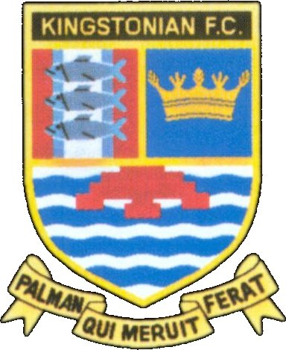

KINGSTONIAN FC

PRESS RELEASE

FUNDRAISING WITH THE GOLD BOND “SUPER DRAW”

As some of you are aware Tom Dixon together with a couple of other members of the club have been working on introducing the above as a proven and sustained way of how a club can greatly increase its fundraising income. The scheme is run by Blackpool F.C. Development Association (this is a completely separate legal entity from Blackpool Football Club) and is up and running at 44 Football League, semi-professional and other organisations. The fund gives away on a yearly basis: -

4 New Cars

8 X Monthly Jackpot £5,000 Cash Prizes

40 X Weekly Jackpot £2,000 Cash Prizes

Other Weekly Prizes; £500, 2 X £200, 7 X £100, 7 X £50, 35 X £25, plus approximately 400 consolation Prizes of £10 and £5. (£10 increases to £20 on £5,000 and Car Draw weeks).

What is The Gold Bond “Super Draw?” Well it is: -

- A lottery devoted to supporting sport and charities in a joint effort.

- It costs NOTHING for us as a club to join.

- There are no set-up charges for us to find and no weekly fees.

- We have been offered a plan to convert our current membership of draw schemes, free of charge.

- We will be supplied with membership cards, introductory letters, posters, handbills, agent recruiting circulars and weekly result sheets free of charge.

- We are being offered a full back-up sales and promotion service for the K’s. We will be given assistance in promoting our own K’s lottery.

- Lastly the more effort we put in the more support we will receive from K’s own Gold Bond “Super Draw.”

What income do we get?

The K’s will receive the following donations based on whatever our paid up membership is each week: -

Paid Membership Donation % Actual Weekly Donation

Up to 250 50 £125
251 - 500 55 £138 - £275
501 - 2,500 60 £300 - £1,500
2,501 - 3,500 62.5 £1,563 - £2,187
3,500 + 65 From £2,275

What can you do to help?

Go around the town putting up “Flyers.”
Become a collector for the Kingstonian Gold Bond “Super Draw.”
Simply agree to participate in the scheme.
Persuade small local businesses and pubs to get involved.
If you work in or know a large company set up a company scheme.
Deliver FreePost application forms door to door.

How will you know if you have won?

Your collector will bring you a full result sheet every week.

The results will be published on the K’s website.

Hopefully they will also be published in the local press.

Want to know more?

Please see either Tom Dixon, Anup Khosla or Graham Richards at the club.
At present we are on schedule to take our place in the December draw.

Do you remember this slogan at all?

“YOU CAN’T WIN IT IF YOU’RE NOT IN IT!”

